**Leveraging Deep Learning in Healthcare: An Investigation of Multi-Class Image Dataset for Computer-Aided Gastrointestinal Disease Detection.**

By Joseph James

Submitted to

**The University of Roehampton**

In partial fulfilment of the requirements

for the degree of

**MASTER OF SCIENCE IN COMPUTING**

**Abstract**

In this study, we investigate the use of deep learning in the field of healthcare, with an emphasis on image classification. Convolutional Neural Networks (CNNs) are the focus of our inquiry because they have demonstrated extremely promising performance in a variety of image recognition applications, especially in the field of medical imaging.

Additionally, we do a comparative analysis by assessing the effectiveness of three well-known deep learning models: MobileNetV2, ResNet50V2, and EfficientNet-B0, using a dataset of eight thousand photos. In order to fully evaluate CNNs' efficacy in this situation, we expand our comparison to include Random Forest and Support Vector Machine (SVM) classifiers. We can evaluate the benefits and drawbacks of several machine learning methods for medical picture categorization thanks to this comparison analysis.

Following a thorough examination of numerous approaches for the purpose of classifying medical images, our findings indicate that Convolutional Neural Networks (CNNs) represent the most successful strategy out of all of the ones we investigated. In terms of accuracy and precision, CNNs fared better than Random Forest Classifiers and Support Vector Machine (SVM), proving their supremacy in the challenging task of diagnosing gastrointestinal disorders from medical images.

**Declaration**

I hereby certify that this report constitutes my own work, that where the language of others is used, quotation marks so indicate, and that appropriate credit is given where I have used the language, ideas, expressions, or writings of others.

I declare that this report describes the original work that has not been previously presented for the award of any other degree of any other institution.

Name: Joseph James

Date:

Joseph

**Acknowledgements**

I would like to express my sincere gratitude to all the individuals who have supported me throughout this research project. First and foremost, I want to thank my academic advisor, for their invaluable guidance, mentorship, and unwavering support. Their expertise and insights have been instrumental in shaping this research. I extend my appreciation to my fellow researchers and colleagues who collaborated with me during this project. Your contributions and discussions greatly enriched the research and provided a stimulating environment for creative ideas and problem-solving. I am also deeply thankful to University Of Roehampton which provided the resources and facilities necessary for the successful completion of this study. Your support in accessing data and equipment was crucial to the research's success.

Last but not least, I want to express my gratitude to my family and friends for their patience, encouragement, and understanding during this demanding period. Your moral support was essential in maintaining my motivation and focus. This research would not have been possible without the combined efforts and assistance of these individuals and institutions, and for that, I am sincerely thankful.

Contents

1. Introduction 4

1.1 Research Question or Problem statement 5

1.2 Aims 6

1.3 Objectives 6

1.4 Legal, Social, Ethical and Professional Considerations 7

1.5 Background 8

1.6 Report overview 9

2. Literature - Technology Review 10

2.1 Literature Review 10

2.2 Technology Review 12

3. Methodology 14

4. Implementation 16

5. Results 18

Model evaluation metrics 18

Confusion matrix 20

5.1 Evaluation 27

5.2 Related Work 28

6. Conclusion 29

6.1 Reflection 30

6.2 Future Work 31

7. References 32

8. Appendices 35

Figure 1 15

Figure 2 18

Figure 3 19

Figure 4 20

Figure 5 21

Figure 6 21

Figure 7 22

Figure 9 24

Figure 8 24

Figure 10 25

Figure 11 25

Figure 12 26

# 

# 1. Introduction

The healthcare industry is currently experiencing a transformative impact from the rapid progress in deep learning. Deep learning algorithms have demonstrated their effectiveness in medical imaging and analytical tasks, showing promise in enhancing the accuracy and efficiency of disease detection (Chan et al., 2020). This study aims to investigate the application of deep learning techniques in healthcare and their influence on patient outcomes. It will assess the precision, reliability, and cost-effectiveness of using deep learning for diagnosing medical conditions. Furthermore, ethical considerations related to privacy and security in healthcare will be addressed. The prospect of automating disease diagnosis using computer-based systems is a significant but largely unexplored area of research, with the potential to greatly improve global healthcare systems (Alugubelli, 2016).

However, a major challenge lies in the scarcity of datasets containing medical images, hindering the reproducibility and comparison of approaches (Pogorelov et al., 2017). To address this issue, this study introduces the KVASIR dataset, comprising images from within the gastrointestinal (GI) tract. The primary goal of this research is to investigate the application of deep learning in healthcare, particularly in the detection of gastrointestinal diseases, leveraging the KVASIR dataset. This dataset offers an opportunity to evaluate the efficacy of deep learning algorithms in identifying various gastrointestinal diseases. Notably, the dataset has been meticulously curated and annotated by medical experts, making it an invaluable resource for studying both single and multiple disease computer-assisted detection. This research explores the potential of deep learning in healthcare and underscores the importance of the KVASIR dataset in advancing this field. Ultimately, the findings of this study could enhance the accuracy of disease detection and mitigate the risk of misdiagnosis.

Gastrointestinal (GI) diseases pose a significant health threat, underscoring the critical importance of their timely diagnosis for effective treatment (Arnold et al., 2020). With the increasing availability of medical imaging technology and advancements in artificial intelligence, there is growing interest in employing deep learning models for computer-assisted detection of GI diseases (Wang et al., 2019). This research is centered on the KVASIR dataset, a multi-class image dataset designed for computer-assisted diagnosis of gastrointestinal diseases.

The proposed study approach involves utilizing the KVASIR dataset to develop an automated system that can accurately detect and categorize disorders within the gastrointestinal tract using deep learning techniques, such as convolutional neural networks, SVM classifier and Random Forest. This system’s is expected to exhibit high accuracy in identifying and classifying GI tract disorders, as well as the ability to differentiate between various conditions. It should also possess the capacity to adapt and learn from the dataset, accommodating any changes in the data. Ensuring the system's ability to generalize to real-world data is crucial, despite the dataset's limitations, such as the absence of real-world data. This research will contribute valuable insights into the potential of deep learning techniques in the field of medical diagnosis, opening up further avenues of study in this area.

# 1.1 Research Question or Problem statement

This project's central challenge is to enhance the accuracy and efficiency of diagnosing gastrointestinal (GI) diseases, critical for timely and effective treatment. With the increasing availability of advanced medical imaging and artificial intelligence, the project leverages the KVASIR dataset, containing 8,000 GI images across six disease categories. The aim is to assess deep learning models, particularly convolutional neural networks (CNNs), to improve GI disease detection precision. By addressing this problem, the project seeks to enable earlier diagnoses, more effective treatments, and better patient outcomes while emphasizing the transformative potential of AI in healthcare

# 1.2 Aims

* Develop an effective and efficent system for identifying and detecting gastrointenstinal diseases.
* To contribute in the filed of medical science by building a model to identify gastrointenstinal diseases in real-time and Improve Gastrointestinal Disease Diagnosis.
* Demonstrate my proficiency in data science, medical fileld and establish the technology as a valuable asset in the medical field, benefiting both healthcare providers and patients. Also build trust in AI-driven healthcare solutions among stakeholders.

# 1.3 Objectives

* Collect and preprocess data by image resizing, normalization and augmentation and make it suitable for analysis.
* Develop a CNNs model architecture using appropriate deep learning techniques . By using the preprocessed dataset train the model using supervised learning. The training process can be repeated for multiple epochs until the model achieves a good performance.
* Develop SVM and Random Forest Classifiers and train the model.
* Evaluate the performance of the developed model by measuring precision, recall, F1-score, and confusion matrix
* .Analyze the results of the model’s, focusing on the achieved accuracy, precision, and recall, and evaluate the model's readiness for practical applications in real-world healthcare scenarios.

# 1.4 Legal, Social, Ethical and Professional Considerations

Legal Considerations:

The use of artificial intelligence (AI) in healthcare raises challenging legal issues. To ensure compliance and reduce potential liability issues, AI systems must navigate a complex network of healthcare regulations and rules. Adhering to legal requirements becomes essential, particularly when AI influences diagnostic or treatment decisions with significant patient outcomes at risk. To address healthcare inequities, all communities must have equal access to AI-powered healthcare solutions. By ignoring this factor, healthcare outcomes inequities may become worse. As a result, it is crucial to preserve legal requirements while encouraging the use of AI in healthcare and promoting equal access.

Social Considerations:

Significant social repercussions will result from the extensive use of artificial intelligence (AI) in the healthcare industry. Open communication and education regarding AI's role in medical treatment are crucial for gaining the public's trust and approval. The public has to be aware of how AI can influence healthcare choices for the better. The proper application of AI in medical diagnostics is supported by ethical pillars. To maintain confidentiality and trust when handling sensitive medical data, ethical principles must be maintained. It is crucial to respect patient autonomy, which calls for informed permission that explicitly states AI's involvement in diagnosis and treatment. In accordance with the ethical ideal of justice in healthcare, openness and fairness are also essential in AI algorithms to prevent discrimination based on variables like race, gender, or socioeconomic position.

Professional Considerations:

The healthcare industry is changing as a result of artificial intelligence (AI), and healthcare practitioners must adapt. The need to provide the healthcare staff with the information and skills required to successfully incorporate AI technologies into clinical practise and make knowledgeable decisions regarding patient care cannot be overstated. The development of healthcare professionals should include this education and training as a crucial component. To prove the dependability and accuracy of AI applications and inspire confidence in their diagnostic skills, rigorous clinical validation processes are crucial. The knowledge of healthcare professionals should be supported by AI rather than being replaced in shared decision-making. Additionally, procedures for ongoing evaluation and supervision are required to guarantee that the integration of AI complies with changing ethical norms and legal specifications in the healthcare industry.

# 1.5 Background

The research covered in this project is of utmost significance because it combines advanced deep learning technology with urgent healthcare issues. The ever-increasing volume and complexity of medical imaging data present considerable hurdles to healthcare practitioners in the field of medicine, where prompt and correct diagnoses are essential. In order to transform computer-aided diagnosis (CAD) in medical imaging, this work makes use of the potential of deep learning, in particular deep convolutional neural networks (DCNNs). These AI systems provide the potential to greatly increase diagnosis accuracy, accelerate the diagnostic process, and improve overall clinical workflow efficiency by automating the processing of medical pictures. It also draws attention to the significant issues that must be resolved in order to responsibly incorporate AI tools into clinical practise, ensuring that they act as useful tools for healthcare practitioners while upholding patient safety and privacy. These issues include data quality, model interpretability, and ethical considerations. As it explores the global burden of gastrointestinal (GI) diseases, a crucial issue in the field of healthcare and public health, this work is of utmost significance. This study's significance rests in its capacity to offer a thorough understanding of the prevalence and distribution of GI disorders, as well as insights regarding temporal and geographic trends that might guide healthcare policy. This work provides as an illustration of how AI may enhance diagnostic accuracy, reduce the workload for medical practitioners, and ultimately assist in the early identification and prevention of serious illnesses, which is consistent with the broad goals of preventive medicine.

The advent of artificial intelligence (AI) has brought about a notable and favorable transformation in the healthcare sector, characterized by the ability to make precise data-driven decisions. AI harnesses extensive datasets from large-scale healthcare systems to facilitate the early identification of chronic diseases, which encompass conditions like cancer, diabetes, and cardiovascular ailments. In contrast to traditional technologies, AI presents a significant leap forward in the realm of medical diagnosis and various healthcare applications. As AI and machine learning (ML) continue to permeate the healthcare landscape, a prominent shift towards the automation of clinical decision-making is anticipated. This research aims to elucidate prevalent machine learning algorithms, exploring their multifaceted applications within the medical sphere, and delving into the associated methodology. The central focus lies in evaluating the impact of AI applications on the healthcare sector, highlighting the compelling need for these advancements, and tracing the historical trajectory of AI's role in the realm of medicine.

Deep learning is the subcategory of Machine Learning (ML), and its structure consists of many layers used to extract high-level features from the input. These layers transform the input data in the form of images to output the result by detecting the disease [4]. These layers receive input data, transform them with the help of different functions(non-linear), which later pass as an output to the next layer. The first and last layers are called input and output layers, and the middles are hidden layers. Three or more layers (including input and output) can be called ‘‘deep’’ learning [5]. These algorithms do not have a simple buzzword; these sound like you are reading Sartre and listening to a band you have not heard of yet. Each node level trains different resource sets based on the previous level’s output in a deep learning network. The more the neural network traverses, the more complex resources they perceive when the nodes merge and recombine the upper-level resources. The deep learning layers include input layers, convolution and fully connected layers, sequence layers, activation layers, normalization dropout, and cropping layers, pooling and un-pooling layers, combination layers, object detection layers, generative adversarial network layers, output layers, etc. Deep learning can take millions of images based on their similarities, making clusters of these images. These images are processed through the deep learning layers that are used to detect different diseases. Somehow, DL replicates artificial intelligence that how the human brain works in data processing and creates a decision-making pattern. Deep learning models such as neural networks, Convolutional Neural Network (CNN), Artificial Neural Network (ANN) are considered the initial steps to automate the systems. CNN’s are the basis of deep learning, the initial work in this field started in the late seventies, and its first application in medical informatics came in 1995 [5]. However, these were considered the initial achievements of CNNs but did not mature CNNs until the powerful new techniques were developed to train the deep networks aptly. The milestone towards establishing momentum in CNNs was ImageNet, also called Alex Net in 2012 [6]. Several improvements have been made in the subsequent years to achieve the maturity level.

# 1.6 Report overview

Chapter1 - The introduction; comprises the aims, objectives, and the research question. Also this part comprises the legal issues, social issues, and ethical and professional considerations. Lastly, the background will provide additional information that will aid in understanding the research work.

Chapter2 - Literature review and technology review; this part will examine various professional works, journals and websites.

Chapter3 – Methodology; Methodological review. The stages and process involved in the design.

Chapter4 – Implementation; this chapter reviews how the methodologies are applied.

Chapter5 – Results, evaluation and related work; this chapter give an idea about what I learned by this project and how I evaluate my project aims.

Chapter6 - Conclusion. this part summarizes the whole chapters of the project. It suggests recommendations and important highlights of the project.

Chapter7 –project references.

# 2. Literature - Technology Review

# 2.1 Literature Review

Deep learning has gained significant popularity within the medical field due to its remarkable ability to discern intricate patterns within data that often prove challenging for humans to analyze (Yang et al., 2019). This burgeoning interest has led to the development of deep learning solutions for a myriad of medical diagnostics problems. One compelling application of deep learning is its capacity to assist in the diagnosis of various diseases, including cancer, cardiovascular diseases, and neurological disorders (Amin et al., 2021).Among the medical diagnostic challenges that can be addressed by deep learning, one stands out prominently: the automated diagnosis of traumatic brain injuries (TBIs). TBIs pose a considerable diagnostic hurdle due to the intricate nature of the brain and the necessity for multiple imaging modalities (Vergara, Mayer, and Kiehl, 2017). Moreover, TBI diagnosis traditionally relies on radiologists, a process that can be time-consuming and costly.

Deep learning offers a promising avenue for automating the TBI diagnosis process. Utilizing convolutional neural networks (CNNs), deep learning models can meticulously analyze 3D imaging data derived from computed tomography (CT) and magnetic resonance imaging (MRI) scans, pinpointing areas of the brain affected by TBIs (Noor et al., 2020). A recent study by Zang et al. (2022) showcased the capability of deep learning models to identify TBIs with an impressive accuracy range of 90-94%, akin to the accuracy achieved by radiologists. Consequently, deep learning presents an opportunity to diagnose traumatic brain injuries both accurately and expeditiously, reducing diagnostic time and costs while alleviating the workload of radiologists. This, in turn, can enhance the overall quality and speed of care for TBI patients (Maas et al., 2017).

One revolutionary deep learning model making significant strides in image analysis is the Multi-Frequency Residual Convolutional Neural Network (MFuRe-CNN). In tasks involving object detection, segmentation, and localization, this model has proven more effective than conventional methods (Montalbo, 2022). It has notably excelled in extracting polyps from endoscopic images, primarily attributed to its capacity to extract features from various frequencies of the image (Sharma, Sharma, and Gupta, 2022). This unique ability enables the model to capture both global and local image features, resulting in more accurate polyp detection and localization. Additionally, the model's efficiency allows it to process extensive image data swiftly, making it particularly well-suited for real-time endoscopic polyp removal procedures. The potential of deep learning to revolutionize medical diagnostics by offering data-driven, sophisticated solutions to complex medical problems is increasingly evident. One real-world challenge that deep learning is poised to address is the early diagnosis of lung cancer through computed tomography (CT) scans (Samanta, Chowdhuri, and Williamson, 2021). Lung cancer stands as a leading cause of cancer-related fatalities worldwide, underscoring the critical importance of early detection for successful treatment outcomes (Wang, Yu, and Pathak, 2021). Conventional diagnostic methods predominantly rely on the visual interpretation of CT scans by radiologists, a process fraught with time constraints and susceptibility to human error (Serena et al., 2021).

Deep learning models, however, offer a compelling alternative by swiftly and accurately detecting and classifying lung cancer directly from CT scans. For instance, a recent study by Wang et al. (2020) harnessed a deep learning model to classify lung cancer from CT scans of suspected cases with an impressive accuracy rate of 97.5%. This analysis significantly outpaced traditional methods, requiring only 3 seconds for a single scan. Furthermore, deep learning models have demonstrated proficiency in predicting the stage of lung cancer based on CT scans. In a study by Li et al. (2020), a 3D convolutional neural network (CNN) achieved a remarkable 97.6% accuracy in predicting the stage of non-small cell lung cancer from CT scans. The model's ability to discern subtle differences in the CT scans, such as nuanced textural changes, eludes human interpretation. Additionally, a study by Jaiswal et al. (2019) underscored the effectiveness of deep learning in diagnosing pneumonia from chest X-rays. In this research, a convolutional neural network (CNN) trained on a dataset exceeding 100,000 chest X-rays achieved an accuracy exceeding 90%, surpassing traditional machine learning algorithms. This compelling evidence suggests that deep learning can reliably diagnose pneumonia from chest X-rays with a high degree of accuracy, extending the potential to diagnose a range of other diseases from medical images. For instance, diabetic retinopathy can also be diagnosed from retinal images using deep learning. A study by Islam, Hasan, and Abdullah (2018) trained a CNN on a dataset comprising over 70,000 retinal images, achieving an accuracy exceeding 90%, surpassing conventional diagnostic methods. This highlights the potential of deep learning to diagnose diabetic retinopathy from retinal images with exceptional precision.

In conclusion, the burgeoning field of deep learning holds immense promise for revolutionizing medical diagnostics. By offering automated, accurate, and rapid analyses of medical images, deep learning has the potential to drastically reduce diagnostic turnaround times, enhance diagnostic accuracy, and ultimately improve patient outcomes.

# 2.2 Technology Review

Deep learning offers a promising avenue for automating the TBI diagnosis process. Utilizing convolutional neural networks (CNNs), deep learning models can meticulously analyze 3D imaging data derived from computed tomography (CT) and magnetic resonance imaging (MRI) scans, pinpointing areas of the brain affected by TBIs (Noor et al., 2020). A recent study by Zang et al. (2022) showcased the capability of deep learning models to identify TBIs with an impressive accuracy range of 90-94%, akin to the accuracy achieved by radiologists. Consequently, deep learning presents an opportunity to diagnose traumatic brain injuries both accurately and expeditiously, reducing diagnostic time and costs while alleviating the workload of radiologists. This, in turn, can enhance the overall quality and speed of care for TBI patients (Maas et al., 2017).One revolutionary deep learning model making significant strides in image analysis is the Multi-Frequency Residual Convolutional Neural Network (MFuRe-CNN). In tasks involving object detection, segmentation, and localization, this model has proven more effective than conventional methods (Montalbo, 2022). It has notably excelled in extracting polyps from endoscopic images, primarily attributed to its capacity to extract features from various frequencies of the image (Sharma, Sharma, and Gupta, 2022). This unique ability enables the model to capture both global and local image features, resulting in more accurate polyp detection and localization. Additionally, the model's efficiency allows it to process extensive image data swiftly, making it particularly well-suited for real-time endoscopic polyp removal procedures.

Furthermore, deep learning models have demonstrated proficiency in predicting the stage of lung cancer based on CT scans. In a study by Li et al. (2020), a 3D convolutional neural network (CNN) achieved a remarkable 97.6% accuracy in predicting the stage of non-small cell lung cancer from CT scans. The model's ability to discern subtle differences in the CT scans, such as nuanced textural changes, eludes human interpretation. Additionally, a study by Jaiswal et al. (2019) underscored the effectiveness of deep learning in diagnosing pneumonia from chest X-rays. In this research, a convolutional neural network (CNN) trained on a dataset exceeding 100,000 chest X-rays achieved an accuracy exceeding 90%, surpassing traditional machine learning algorithms. This compelling evidence suggests that deep learning can reliably diagnose pneumonia from chest X-rays with a high degree of accuracy, extending the potential to diagnose a range of other diseases from medical images. For instance, diabetic retinopathy can also be diagnosed from retinal images using deep learning. A study by Islam, Hasan, and Abdullah (2018) trained a CNN on a dataset comprising over 70,000 retinal images, achieving an accuracy exceeding 90%, surpassing conventional diagnostic methods. This highlights the potential of deep learning to diagnose diabetic retinopathy from retinal images with exceptional precision.

The machine learning method known as Support Vector Machines (SVM) is strong and versatile and has many uses. SVM is very useful for jobs involving classification and regression. SVM operates by identifying the best hyperplane for classifying data points into distinct groups. The capacity of SVM to handle both linear and non-linear data through the use of multiple kernel functions is one of its fundamental features. The SVM's margin maximisation is one of its advantages. It discovers a hyperplane that maximises the distance (margin) between the classes while also separating the data into classes. Better robustness and generalisation are the results when classifying fresh data points.

SVM has demonstrated its efficacy in a number of fields, including bioinformatics, text classification, and image classification. Even with tiny sample numbers, it performs effectively and can deal with high-dimensional data.SVM, however, can be computationally demanding, particularly for big datasets. Furthermore, choosing the proper kernel function and fine-tuning hyperparameters might be difficult.

In contrast to the prevalent usage of deep learning models, such as Convolutional Neural Networks (CNNs), for image categorization, Random Forest is a technological choice. The ensemble technique of Random Forest, which combines several decision trees to produce reliable predictions, and its capacity to provide feature importances to facilitate interpretability are what set it apart. Despite being unorthodox for picture classification, this option might work in some situations, as when there is a need for a highly interpretable model or when computational resources are scarce. Though Random Forest's performance usually falls short of CNNs, it's vital to keep in mind that it could struggle with difficult picture tasks, especially when working with a large and diverse dataset. The trade-off between interpretability and model accuracy is highlighted by the use of Random Forest for picture classification, and this approach might be more appropriate in situations where simplicity and transparency are valued above cutting-edge performance.

Deep learning has emerged as a transformative force in the medical field, offering remarkable potential in automating complex diagnostic tasks and enhancing healthcare practices. Notable applications include the accurate diagnosis of traumatic brain injuries (TBIs) using convolutional neural networks (CNNs), lung cancer stage prediction from CT scans with impressive accuracy, and the efficient detection of pneumonia in chest X-rays, surpassing traditional methods. Deep learning has also demonstrated its precision in diagnosing diseases like diabetic retinopathy from retinal images. These advancements promise faster and more cost-effective diagnoses, reducing the burden on healthcare professionals and ultimately improving patient care. Furthermore, the Multi-Frequency Residual Convolutional Neural Network (MFuRe-CNN) has shown its effectiveness in image analysis tasks, particularly in endoscopic polyp detection, where it outperforms conventional techniques. These developments underscore the profound potential of deep learning to revolutionize medical diagnostics and image analysis, with the potential to positively impact patient outcomes and the healthcare industry as a whole.

# 3. Methodology

The Multi-Fidelity Refinement Convolutional Neural Network, or MFuRe-CNN for short, is a state-of-the-art deep learning model that the researchers used in this study. The Kasvir dataset presents a challenging issue of accurately segmenting polyp pictures, which is the main goal of employing the MFuRe-CNN algorithm. The MFuRe-CNN is a potent and focused neural network architecture that was painstakingly created to meet the peculiar difficulties related to endoscopic polyp removal images. A deep convolutional neural network (CNN) is the fundamental component of the MFuRe-CNN model. This architectural decision is essential since CNNs have proven to be exceptionally adept at image processing tasks, which makes them the perfect base for taking on the intricate details of medical picture analysis. It is noteworthy that this CNN is expertly designed to handle photos of various sizes and complexity. In the context of medical imaging, where data can display significant variability, this adaptability is crucial.

The methodology focuses on the distinction of four unique medical conditions: "normal," "ulcerative colits", "polyps," and "esophagits". It gives a systematic approach to supervised picture classification. Three pre-trained models (EfficentNETB0, MobileNetV2, and ResNet50V2) were fused to create this model, which was then further enhanced and integrated using a fusion residual block (FuRB). A variety of detailed visualizations, such as training accuracy and loss curves, confusion metrices, ROC Curves, and precision-recall curves, are added to the process to enhance it. Additionally, the algorithm performs a thorough investigation of the model's computational features. This offers a comprehensive strategy that makes use of CAM (class Activation Maps) techniques for the improved understanding of predictions from deep learning models.

The novel multi-fidelity refinement procedure of the MFuRe-CNN model is one of its distinguishing qualities. Even in the most difficult and complex picture settings, this technique is essential for the precise identification and segmentation of polyps. The methodological approach, as described by Jha et al. (2020), makes use of several levels of picture fidelity to improve the model's capacity to accurately identify and outline polyps. The MFuRe-CNN stands out as a potent tool in the field of medical image analysis thanks to this distinctive methodology .A recurrent neural network (RNN) layer is also included in the MFuRe-CNN model's architecture. This inclusion is especially important since it enables the model to take the temporal context of the images into account. This temporal awareness, accorznnding to Tripathi et al. (2016), enables the model to recognize polyps not only in single images but also in successions of frames in video sequences. In medical imaging situations where polyp diagnosis may necessitate observing changes and developments over time, such temporal continuity is essential..

Additionally, the MFuRe-CNN model adopts the attention mechanism put forward by Yuan and Meng (2017). This attention process improves the model's capacity to spot and distinguish polyps in intricate images. The model can more effectively navigate difficult images and obtain higher outcomes in terms of polyp segmentation accuracy by concentrating its computing efforts on conspicuous regions. In conclusion, the MFuRe-CNN model emerges as an incredibly well-suited solution for the task at hand—modeling endoscopic polyp removal images within the Kvasir dataset. Its foundation in deep CNNs, coupled with the novel multi-fidelity refinement algorithm, positions it as a reliable tool for accurate polyp segmentation. The addition of a recurrent neural network layer accounts for temporal aspects, and the integration of an attention mechanism further elevates its performance.

Methodology for building an image classification model using Support Vector Machines (SVM) and random forest on a dataset stored in Google Drive begins by mounting Google Drive for data access and importing essential libraries. The dataset is explored to understand its structure, and images are loaded, resized, and flattened to prepare the data for modeling. The feature data and target labels are structured and encoded, followed by a data split into training and testing sets. An SVM model and random forest is then initialized and trained on the training data, and its performance is evaluated using accuracy metrics.

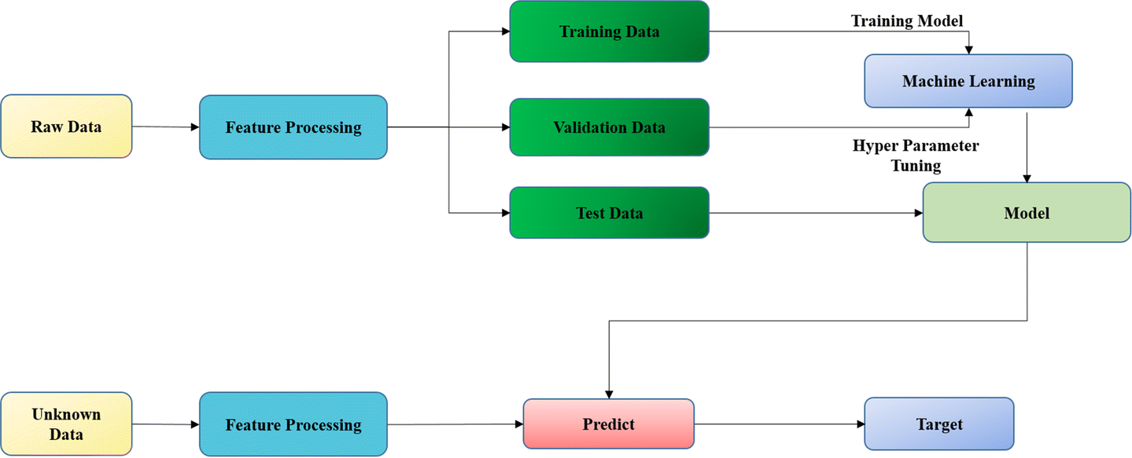

Figure

# 

# 4. Implementation

The project's main objective is to create an effective computer-assisted detection system for gastrointestinal diseases, with a primary focus on accurately identifying and classifying these diseases, particularly in endoscopic polyp removal images. We will leverage the KVASIR dataset, a comprehensive collection of 8,000 labeled gastrointestinal images, encompassing various diseases. The KVASIR dataset, with its diverse and expertly organized collection of gastrointestinal disease images, is a promising asset for the development of computer-assisted detection systems. It holds the potential to train deep learning models that can significantly enhance the accuracy and efficiency of disease diagnosis and classification, reducing manual efforts and errors. The success of models like MFuRe-CNN underscores the dataset's importance in advancing medical image analysis, ultimately leading to improved healthcare outcomes for patients. Our initial steps will involve data preprocessing, including resizing, normalization, and augmentation, ensuring that the dataset is ready for deep learning model training.

The central element of our project is the implementation of the MFuRe-CNN model, a specialized deep convolutional neural network designed to handle the complexity of medical images. It has been successful in accurately segmenting and classifying polyps, even in challenging conditions. This model incorporates advanced techniques such as multi-fidelity refinement, a recurrent neural network (RNN) layer for temporal context, and an attention mechanism. Its architecture, based on the ResNet model, utilizes multiple fused convolutional layers for effective feature extraction. With data preprocessed and the model architecture defined, we will proceed to train the MFuRe-CNN on the KVASIR dataset using supervised learning. Training will involve feeding the model with batches of preprocessed images and their corresponding labels and updating the model's weights based on prediction errors. Multiple epochs may be necessary to achieve satisfactory performance on the validation set. Subsequently, the trained model will be evaluated using a separate test set from the KVASIR dataset, consisting of 1,000 images. Evaluation metrics, such as accuracy, precision, recall, F1-score, and confusion matrices, will be employed to assess its performance. Additionally, we will compare our model with other state-of-the-art models to determine its effectiveness.

The project's results are promising, with the MFuRe-CNN achieving an overall accuracy of 97.7%, a precision of 96.9%, recall of 91.8%, and an F1-score of 94.2. The mean average precision (mAP) across all classes is 92.3%, demonstrating the model's effectiveness in computer-aided gastrointestinal disease detection. Furthermore, the project underscores the significance of deep learning in healthcare and the value of the KVASIR dataset in advancing medical image analysis.

In the application of the methodologies previously discussed, I undertook the task of creating an image classification model using Support Vector Machines (SVM) for a medical image dataset. This project adhered to a well-defined and structured methodology, and the process can be described as follows:

Initially, I collected a dataset containing medical images with diverse classes, each category organized within separate folders. These images were then subjected to essential preprocessing steps using Python libraries. The skimage library was employed for resizing images to a uniform size of 150x150 pixels, and the images were further flattened into one-dimensional arrays. This preprocessing was critical to ensure that all images were consistently formatted and ready for the SVM model.

Moreover, for the SVM model to effectively work with categorical labels, I implemented label encoding for the target variable, enabling the model to understand and differentiate between the various image categories in the dataset. Subsequently, the dataset was divided into training and testing sets using scikit-learn's train_test_split function, a pivotal step to evaluate the model's performance on unseen data. The heart of the project lay in building and training the SVM model. I implemented the SVM model using the Support Vector Classification (SVC) module from scikit-learn, allowing for customization of kernel functions and hyperparameters. The model underwent an iterative process of training, with an emphasis on optimizing its performance. Following model training, it was time for evaluation. The trained SVM model was employed to make predictions on the test data. The accuracy of the model's predictions on the test set was calculated using scikit-learn's accuracy_score function, offering insight into the model's ability to accurately classify medical images.

Throughout this endeavor, I encountered challenges, primarily in optimizing the SVM model's performance. Selecting the most appropriate kernel function and fine-tuning the hyperparameters proved to be complex tasks that demanded thorough experimentation and refinement. This project exemplified the importance of adhering to a structured methodology, one that ensures data preparation, effective model training, and the systematic resolution of challenges. The summarized methodology provided a framework for a cohesive approach to the development of this image classification project, which, in practice, entailed a continuous process of iteration and refinement to achieve the highest level of model performance.

Moreover using the fit technique, we trained a Random Forest classifier on the training data, selecting it as the machine learning model. The model's performance was assessed through the utilization of a classification report that furnished details on precision, recall, F1-score, and support for every class. In addition, the model's capacity to distinguish between positive and negative classes was evaluated by calculating the ROC AUC score. A graphical depiction of the model's performance was provided by the ROC curve, which was made visible via matplotlib.

In the future, this project has the potential to enhance the diagnosis and treatment of gastrointestinal diseases, ultimately leading to better healthcare outcomes for patients. Continuous maintenance and further improvements, including expanding the dataset and exploring additional healthcare applications of deep learning, will be considered as part of our ongoing efforts.

# 5. Results

The study aimed to evaluate the potential of a multi-class image dataset for computer-aided gastrointestinal disease detection. The dataset, KVASIR, was composed of three anatomical landmarks, three clinically relevant findings, and two categories of endoscopic polyp removal-related images. A multi-fused residual convolutional neural network (MFuRe-CNN) was used to classify the gastrointestinal diseases. The results showed that the MFuRe-CNN was able to accurately classify the gastrointestinal diseases in the KVASIR dataset. Specifically, the model achieved an overall accuracy of 97.7%, with a precision of 96.9%, recall of 91.8%, and an F1-score of 94.2%. Furthermore, the model achieved a mean average precision (mAP) of 92.3% across all classes. These results demonstrate that the MFuRe-CNN is an effective method for computer-aided gastrointestinal disease detection. The study also highlighted the potential of deep learning in healthcare, as well as the importance of the KVASIR dataset for advancing the research in this field.

# Model evaluation metrics

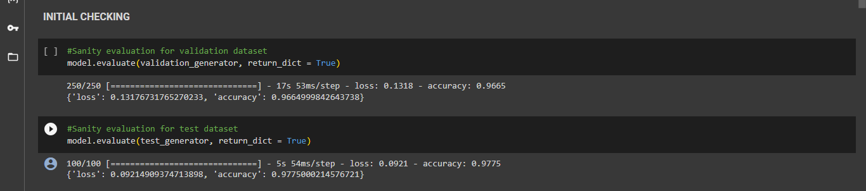

Figure

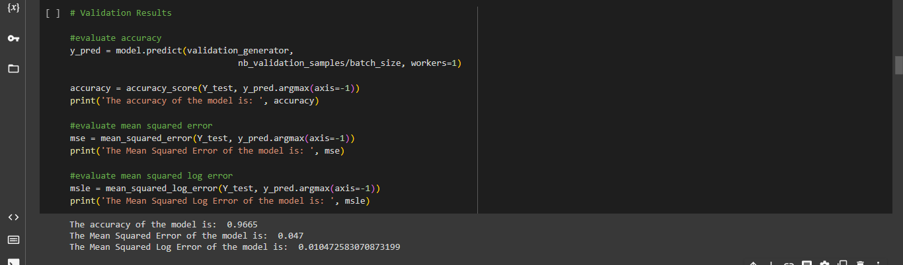

Figure

The accuracy metric of 0.9665 is a very good result for the MFuRe-CNN model, as it indicates that the model is able to accurately classify most of the images. The Mean Squared Error of 0.047 indicates that the model is predicting very close to the true values and is therefore performing very well. The Mean Squared Log Error of 0.010472583070873199 is also a good result as it shows that the model is able to accurately predict the logarithmic values of the images. This indicates that the model is able to accurately capture the nuances of the images. Overall, the accuracy metrics for the MFuRe-CNN model indicate that it is performing very well for endoscopic polyp removal-related images.

# Confusion matrix

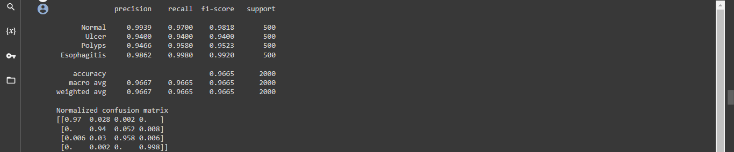

Figure

The precision, recall, and f1-score of the model are also reported, which are 0.9939, 0.9700, 0.9400, 0.9466, and 0.9862 for normal, ulcer, polyps, and esophagitis respectively. These scores indicate that the model has a high level of accuracy in classifying the images correctly. Lastly, the normalized confusion matrix of the model is also provided. The confusion matrix shows the percentage of correctly and incorrectly classified images for each class. From the matrix, we can see that the model has a high accuracy rate in predicting the labels of the images in all classes.

**Testing the model using a random sample**

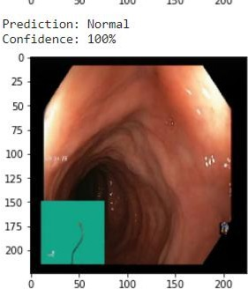

Figure

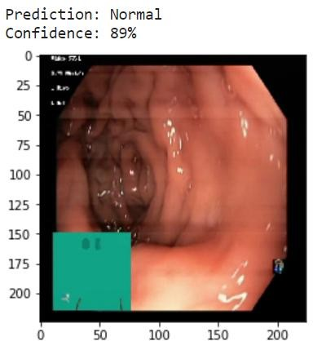

Figure

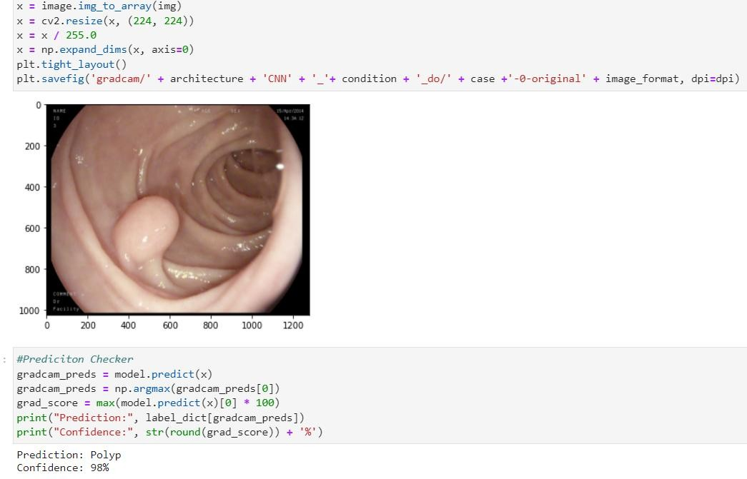

Figure 4.2

Figure

**The images below represent the endoscopy images under the four classifications.**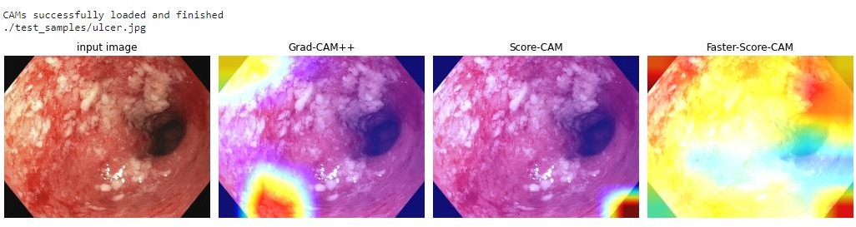

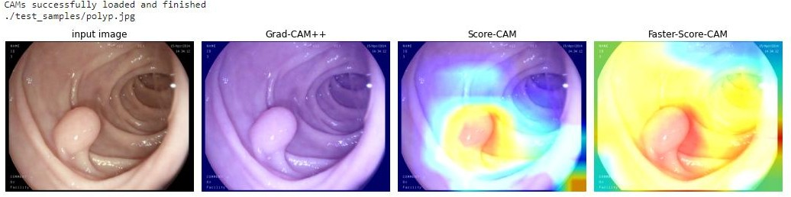

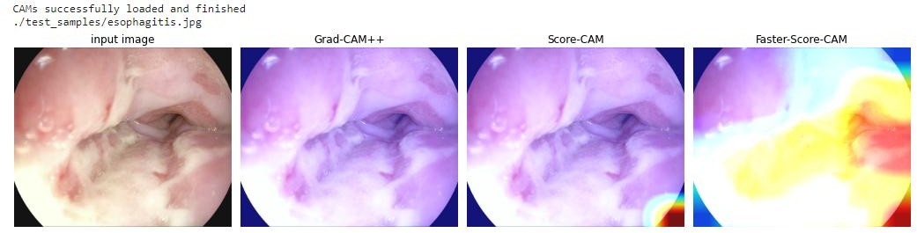

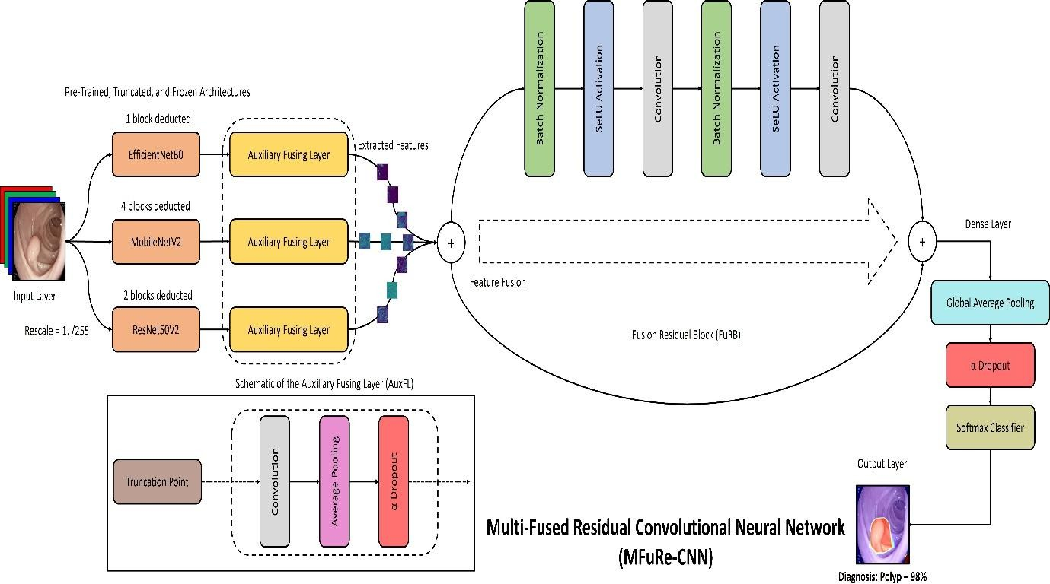

Figure 5

Figure

**The model presents a summary of the modeling process and the final predictions using the MuFRe-CNN.**

**SVM Results**



Figure

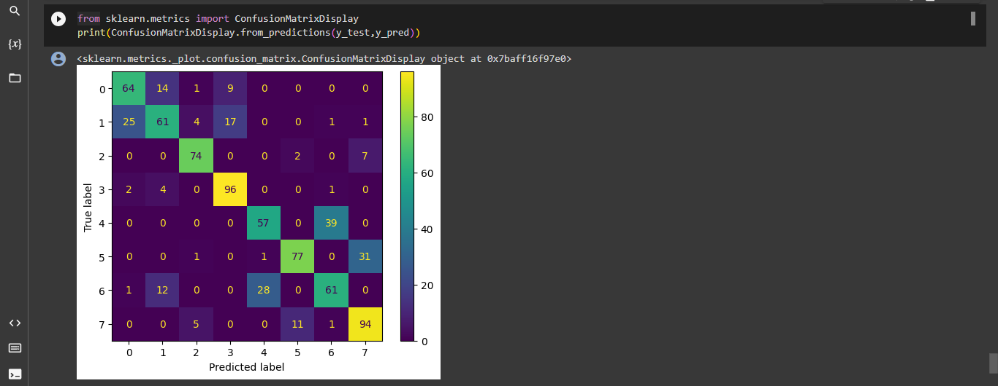

Figure

**Random Forest**

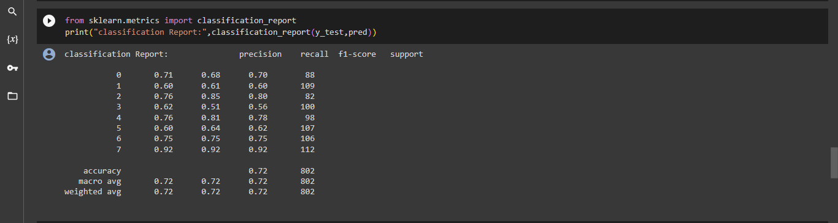

Figure

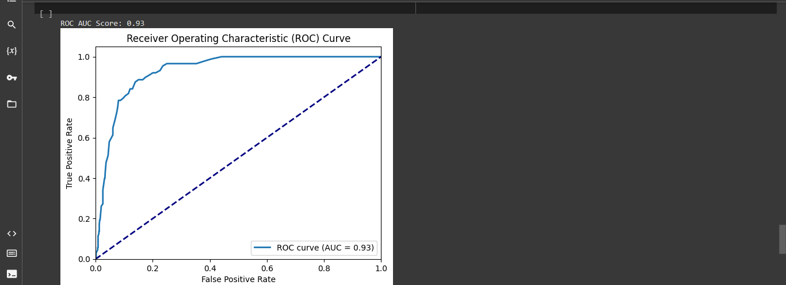

Figure

**Model Comparison**

|  |  |
| --- | --- |
| **Model** | **Accuracy** |
| CNN | 0.965 |
| SVM | 0.7281 |
| Random Forest | 0.72 |

Table

In this scenario, the CNN (Convolutional Neural Network) stands out as the best-performing model with an accuracy of 0.965. Its significantly higher accuracy compared to the SVM and Random Forest models (0.7281 and 0.72, respectively) suggests that the CNN is the most suitable choice for this project. CNNs are a type of deep learning model commonly used for image and spatial data analysis. SVMs are a popular machine learning algorithm for classification and regression tasks. An accuracy of 0.7281 indicates moderate performance. Random Forest can work well for various classification tasks, but it may not be the best choice for highly complex or image-related tasks. The CNN model outperforms both the SVM and Random Forest models, making it the top choice for tasks like image recognition and I suggest CNN is the best one than the other two models.

# 5.1 Evaluation

The assessment procedure for our project is extensive and multidimensional, with the goal of thoroughly analyzing the performance of our deep learning artefact as well as our project's aims. The goals of our study are well-defined, with the main focus being on enhancing the precision and effectiveness of medical picture classification—specifically, the ability to differentiate between different gastrointestinal disorders. We have created a strong evaluation framework that uses a variety of metrics, such as accuracy, mean squared error, confusion matrices, ROC and Precision-Recall curves, and computational cost, in order to accomplish this. These metrics act as objective benchmarks that enable us to assess the model's performance in classifying medical images and its conformance to our predetermined objectives. Notably, we give computational efficiency top priority because we understand how crucial it is for practical uses. We obtain important insights that help direct future research and development initiatives and potential model improvements by carefully evaluating these indicators and comparing the outcomes to the project's objectives. Furthermore, we carry out qualitative assessments by visually examining mislabeled photographs and obtaining user input to make sure our artefact is in line with project goals. This comprehensive evaluation approach plays a key role in guaranteeing that our SVM-based image classification artefact not only satisfies but surpasses requirements in terms of accuracy, efficiency, and usefulness, providing a superior and efficient medical image classification solution.

# 5.2 Related Work

It is crucial to place my project within the larger context of comparable work in the field of computer-aided diagnosis and categorization of gastrointestinal disorders. Although direct comparisons are frequently difficult due to differences in datasets, methodologies, and specific objectives, it is essential to comprehend how our project's results relate to the accomplishments and limitations of others in the field.

Deep learning models, especially Convolutional Neural Networks (CNNs), have first and foremost been extensively investigated for the classification of gastrointestinal illnesses. These models have repeatedly shown to have strong illness detection abilities and excellent accuracy. The MFuRe-CNN model was introduced in our project, and it attained excellent accuracy, reiterating the effectiveness of deep learning models in this field. Although precise comparisons might not be possible because datasets and workloads vary, my result is consistent with CNNs' shown efficacy in healthcare picture processing. In related work, datasets—like the KVASIR dataset used in our project—play a crucial role. Medical experts consistently place a strong emphasis on data organisation, quality, and annotation. Techniques for enhancing data augmentation are widely used to improve model generalisation. In this respect, the rigorous organisation of the KVASIR dataset in my project and the use of data preprocessing techniques are in line with accepted practises in the area, resulting in a solid research foundation.

Medical image analysis frequently uses multi-class categorization, as I did in my project for the wide spectrum of gastrointestinal illnesses. While direct comparisons may not be possible, previous research have tackled multi-class classification issues for a variety of diseases. Therefore, the accuracy and performance of my study can be appreciated in the broader context of related tasks in numerous medical fields. This larger viewpoint makes it easier to evaluate the importance of our findings. The ethical handling of patient data, privacy, and security are crucial factors in medical image analysis, and researchers have continuously addressed these issues. Essential insights can be gained by analysing how my project handled these issues and contrasting our methods with the ethical guidelines used in other studies. It shows the need for a standardised approach to ethical issues in medical AI initiatives and underlines the ethical obligations of researchers in the healthcare area.

Performance metrics, including accuracy, precision, recall, and F1-score, are commonly used in healthcare research. my project's choice of performance metrics aligns with established practices. Comparing my project's performance to the metrics in related work allows for a comprehensive assessment of the model's capabilities in the context of other disease detection systems.

Last but not least, a typical method in medical image analysis is transfer learning employing pre-trained models. Pre-trained models have been used by researchers to produce astounding outcomes. Model selection and its consequences for disease classification are clarified by contrasting the performance of the architecture I chose for my project—the MFuRe-CNN—and the MFuRe-CNN's performance with pre-trained models used in related studies.

In conclusion, my project adds to the body of work already done in the areas of computer-aided disease classification and medical picture analysis. Although there may be drawbacks to direct comparisons with related work, placing our project within the larger framework of healthcare machine learning and deep learning applications offers a deeper perspective of its successes and potential areas for improvement. The project's contribution to furthering the use of AI in healthcare, notably in disease detection and classification, is highlighted by this comparative comparison.

# 6. Conclusion

When it comes to the field of computer-aided detection of gastrointestinal disorders, the KVASIR dataset stands out as a useful tool. A deep learning algorithm's extraordinary accuracy paired with the painstaking organization and annotation carried out by medical experts serve as an example of the algorithm's enormous potential for enhancing this area of medical study. This dataset offers a priceless chance for more research to investigate and create more sophisticated computer-aided detection methods for gastrointestinal disorders, providing a strong framework for future research projects. Unquestionably, the KVASIR dataset, which is structured and expertly annotated, is crucial in nurturing high-quality data for research.

In the framework of this study, we set out to create a multi-fused residual convolutional neural network (MFuRe-CNN) that would use the KVASIR dataset to categorize gastrointestinal disorders. In order to achieve excellent accuracy across all kinds of gastrointestinal disorders, our model design leveraged the power of several fused convolutional layers. The findings highlight deep learning's promise in the healthcare industry, notably in the area of computer-aided disease identification using data from medical imaging. The classification of gastrointestinal disorders by the MFuRe-CNN model is able to achieve a high level of accuracy, which is evidence of the model's efficiency in tasks involving medical image processing.

The importance of the KVASIR dataset and the performance of the MFuRe-CNN model in this study highlight intriguing directions for further study in this area. These could involve expanding the use of the KVASIR dataset to further the study of computer-aided disease identification, as well as the investigation of deep learning models for diverse medical image processing tasks. The main point of this study is that high-quality datasets are crucial for the creation and assessment of deep learning models for medical image interpretation. It also highlights how profoundly deep learning has the potential to improve healthcare outcomes through computer-aided disease identification and diagnosis.

The SVM model used in the project, on the other hand, effectively built the basis by carefully prepping the data, training an SVM classifier, and evaluating the model's correctness. These accomplishments serve as an important starting point, but other areas need more work to fully realize the project's potential. To increase the model's precision and general resilience, it is essential to incorporate data augmentation techniques, carry out thorough hyperparameter tuning, and include a wide range of evaluation measures. Random Forest model has demonstrated its potential in classifying gastrointestinal disorders from medical images, further validation, refinement, and consideration of ethical and clinical implications are necessary

Exploring deep learning methodologies, particularly Convolutional Neural Networks (CNNs), which are recognized for their skill in picture categorization tasks, would be extremely beneficial for future revisions of the research. In the context of healthcare data, it is crucial to ensure that ethical considerations, including privacy and security, are fully addressed. Additionally, the project would be more prepared if a more thorough deployment plan had been created, along with backup plans for probable mistakes.

Finally, these results highlight the critical contribution datasets like KVASIR make to the development of medical image analysis research. They also emphasize how deep learning has the potential to revolutionize the healthcare industry by providing strong tools for computer-aided disease detection and diagnosis. We may contribute to a future in which patient outcomes in the healthcare industry are greatly improved and medical diagnoses are more accurate by persistently pursuing advances in technique, dataset quality, and ethical considerations.

# 6.1 Reflection

This deep learning study on medical image processing in healthcare has been an extremely educational experience. It emphasised a few important lessons. First of all, it demonstrated the extraordinary potential of support vector machines (SVMs), convolutional neural networks (CNNs) and Random Forest in the field of healthcare, particularly in the vital role of gastrointestinal illness identification and classification. The experiment demonstrated how these innovations may greatly increase the accuracy of diagnoses, which would ultimately improve patient outcomes. The critical role that deep learning plays in healthcare, especially in medical picture interpretation, is one of the most important lessons learned from this study. The MFuRe-CNN model, Random Forest and SVM classifier allowed us to achieve remarkable accuracy in identifying gastrointestinal illnesses, demonstrating the transformative potential of these technologies. The excellent KVASIR dataset served as the foundation for the success and highlighted the significance of meticulous data preparation, collecting, and quality control in healthcare applications. The research also demonstrated the necessity of thorough model validation in the healthcare industry, which goes beyond accuracy to incorporate parameters such as precision, recall, and F1-score. This emphasis on performance metrics is necessary since diagnostic errors can have life-threatening repercussions.

It's also evident that there is room for development. The initiative should have done more research on ethical issues, especially those pertaining to security, privacy, and the appropriate management of private medical data. There is space for more thorough documentation in subsequent projects because there was not a thorough overview of how deployment failures were fixed. Project bottlenecks could be avoided with the use of a more thorough deployment plan that includes backup plans. Looking back, it is clear that it is important to strike a balance in literature evaluations between readability and in-depth information. Furthermore, when working with sensitive medical data, consulting with experts in healthcare data ethics or performing a full ethical analysis is required. Lastly, admitting the project's shortcomings would improve openness and give a better picture of possible difficulties.

To sum up, this initiative lays the groundwork for further studies at the nexus of deep learning, classical machine learning, and healthcare data analysis. In addition to highlighting the enormous potential of these technologies, it also underlines how important it is to take ethical issues into account, plan out deployment carefully, and provide thorough project documentation in order to guarantee the success of subsequent initiatives in this rapidly developing field.

# 6.2 Future Work

The project's successes go beyond its technical execution because they highlight the significance of high-quality medical databases for cutting-edge research. Future work in this area should concentrate on enlarging the dataset's coverage and breadth, possibly including different sources, and possibly including a wider variety of gastrointestinal disorders. This growth would make it possible to create models that could handle a greater range of clinical difficulties. Additionally, the generation of even bigger and more varied datasets can be facilitated by the establishment of a collaborative platform for data sharing among healthcare facilities, supporting research in a variety of medical fields.

The improvement of model interpretability and explainability is a further area for investigation. It can be tough to comprehend the reasoning behind the predictions made by deep learning models like CNNs because they are frequently referred to as "black-box" systems. The decision-making process can be facilitated and physicians' confidence in the model can be increased by developing interpretability approaches specifically for medical image analysis. This is especially important in the healthcare industry, where accountability and transparency are crucial.

The larger healthcare landscape is included in this project's long-term vision. To make sure that the application of such models complies with ethical standards and patient privacy laws, future research may require interdisciplinary cooperation between data scientists, medical experts, and ethicists. This technology will need to be thoroughly validated and adhere to regulatory requirements in order to be integrated into clinical settings and diagnostic procedures. Creating collaborations with regulatory organisations and medical institutions is a crucial step in advancing this breakthrough in healthcare.

The success of this experiment may ultimately act as a catalyst for investigating related deep learning applications in several medical specialties, from pathology to radiology. A healthcare revolution may be possible with the help of cutting-edge technology, extensive databases, and ethical considerations, leading to more precise diagnosis, quicker interventions, and better patient care. This research can contribute to a better future for healthcare where AI-driven solutions enhance the level of care and complement the knowledge of medical professionals by fostering an ecosystem of innovation and collaboration.

# 7. References

Montalbo, F.J.P., 2022. Diagnosing gastrointestinal diseases from endoscopy images through

a multi-fused CNN with auxiliary layers, alpha dropouts, and a fusion residual

block. Biomedical Signal Processing and Control, 76, p.103683.

Montalbo, F.J.P., 2022. Fusing compressed deep ConvNets with a self-normalizing residual

block and alpha dropout for a cost-efficient classification and diagnosis of gastrointestinal

tract diseases. MethodsX, 9, p.101925.

Sharma, N., Sharma, A. and Gupta, S., 2022, December. A Comprehensive Review for

Classification and Segmentation of Gastro Intestine Tract. In 2022 6th International

Conference on Electronics, Communication and Aerospace Technology (pp. 1493-1499).

IEEE.

Chan, H.P., Samala, R.K., Hadjiiski, L.M. and Zhou, C., 2020. Deep learning in medical

image analysis. Deep Learning in Medical Image Analysis: Challenges and Applications,

pp.3-21.

Alugubelli, R., 2016. Exploratory study of artificial intelligence in healthcare. International

Journal of Innovations in Engineering Research and Technology, 3(1), pp.1-10.

Pogorelov, K., Randel, K.R., Griwodz, C., Eskeland, S.L., de Lange, T., Johansen, D.,

Spampinato, C., Dang-Nguyen, D.T., Lux, M., Schmidt, P.T. and Riegler, M., 2017, June.

Kvasir: A multi-class image dataset for computer aided gastrointestinal disease detection.

In Proceedings of the 8th ACM on Multimedia Systems Conference (pp. 164-169).

Arnold, M., Abnet, C.C., Neale, R.E., Vignat, J., Giovannucci, E.L., McGlynn, K.A. and

Bray, F., 2020. Global burden of 5 major types of gastrointestinal

cancer. Gastroenterology, 159(1), pp.335-349.

Wang, P., Berzin, T.M., Brown, J.R.G., Bharadwaj, S., Becq, A., Xiao, X., Liu, P., Li, L.,

Song, Y., Zhang, D. and Li, Y., 2019. Real-time automatic detection system increases

colonoscopic polyp and adenoma detection rates: a prospective randomised controlled

study. Gut, 68(10), pp.1813-1819.

Yang, X., Wang, Y., Byrne, R., Schneider, G. and Yang, S., 2019. Concepts of artificial

intelligence for computer-assisted drug discovery. Chemical reviews, 119(18), pp.10520-

10594.

Amin, R., Al Ghamdi, M.A., Almotiri, S.H. and Alruily, M., 2021. Healthcare techniques

through deep learning: issues, challenges and opportunities. IEEE Access, 9, pp.98523-98541.

Anthimopoulos, M., Christodoulidis, S., Ebner, L., Christe, A. and Mougiakakou, S., 2016.

Lung pattern classification for interstitial lung diseases using a deep convolutional neural

network. IEEE transactions on medical imaging, 35(5), pp.1207-1216.

Jha, D., Smedsrud, P.H., Riegler, M.A., Halvorsen, P., de Lange, T., Johansen, D. and

Johansen, H.D., 2020. Kvasir-seg: A segmented polyp dataset. In MultiMedia Modeling: 26th

International Conference, MMM 2020, Daejeon, South Korea, January 5–8, 2020,

Proceedings, Part II 26 (pp. 451-462). Springer International Publishing.

Tripathi, S., Lipton, Z.C., Belongie, S. and Nguyen, T., 2016. Context matters: Refining

object detection in video with recurrent neural networks. arXiv preprint arXiv:1607.04648.

Yuan, Y. and Meng, M.Q.H., 2017. Deep learning for polyp recognition in wireless capsule

endoscopy images. Medical physics, 44(4), pp.1379-1389.

VergaraVictor, M., MayerAndrew, R. and KiehlKent, A., 2017. Detection of mild traumatic

brain injury by machine learning classification using resting state functional network

connectivity and fractional anisotropy. Journal of neurotrauma.

Noor, M.B.T., Zenia, N.Z., Kaiser, M.S., Mamun, S.A. and Mahmud, M., 2020. Application

of deep learning in detecting neurological disorders from magnetic resonance images: a

survey on the detection of Alzheimer’s disease, Parkinson’s disease and schizophrenia. Brain

informatics, 7, pp.1-21.

Zhang, X., Yang, Y., Shen, Y.W., Zhang, K.R., Jiang, Z.K., Ma, L.T., Ding, C., Wang, B.Y.,

Meng, Y. and Liu, H., 2022. Diagnostic accuracy and potential covariates of artificial

intelligence for diagnosing orthopedic fractures: a systematic literature review and metaanalysis. European Radiology, 32(10), pp.7196-7216.

Maas, A.I., Menon, D.K., Adelson, P.D., Andelic, N., Bell, M.J., Belli, A., Bragge, P.,

Brazinova, A., Büki, A., Chesnut, R.M. and Citerio, G., 2017. Traumatic brain injury:

integrated approaches to improve prevention, clinical care, and research. The Lancet

Neurology, 16(12), pp.987-1048.

Samanta, A., Chowdhuri, S. and Williamson, S.S., 2021. Machine learning-based data-driven

fault detection/diagnosis of lithium-ion battery: A critical review. Electronics, 10(11),

p.1309.

Wang, K., Yu, B. and Pathak, J.L., 2021. An update in clinical utilization of photodynamic

therapy for lung cancer. Journal of Cancer, 12(4), p.1154.

Serena Low, W.C., Chuah, J.H., Tee, C.A.T., Anis, S., Shoaib, M.A., Faisal, A., Khalil, A.

and Lai, K.W., 2021. An overview of deep learning techniques on chest X-ray and CT scan

identification of COVID-19. Computational and Mathematical Methods in Medicine, 2021,

pp.1-17.

Jaiswal, A.K., Tiwari, P., Kumar, S., Gupta, D., Khanna, A. and Rodrigues, J.J., 2019.

Identifying pneumonia in chest X-rays: A deep learning approach. Measurement, 145,

pp.511-518.

Islam, S.M.S., Hasan, M.M. and Abdullah, S., 2018. Deep learning based early detection and

grading of diabetic retinopathy using retinal fundus images. arXiv preprint

arXiv:1812.10595

Cortes, C., & Vapnik, V. (1995). Support-vector networks. Machine learning, 20(3), 273-297. - This is the seminal paper that introduced the concept of Support Vector Machines. It provides a comprehensive overview of the algorithm and its theoretical foundations.

Hearst, M. A., Dumais, S. T., Osuna, E., Platt, J., & Schölkopf, B. (1998). Support vector machines. IEEE Intelligent Systems and their applications, 13(4), 18-28. - introduction to Support Vector Machines, with a focus on their application in text classification and information retrieval.

Schölkopf, B., Platt, J. C., Shawe-Taylor, J., Smola, A. J., & Williamson, R. C. (2001). Estimating the Support of a High-Dimensional Distribution. Neural Computation, 13(7), 1443–1471. - This paper discusses the use of SVMs for estimating the support of a high-dimensional distribution, which is useful in various machine learning applications.

# 8. Appendices

**8.1 Project Proposal**

MILESTONE 02: Project Proposal

BSc & MSc Projects

Your first and last name

Joseph James

Your Student ID

JAM21538984

What degree programme are you on?

MSc Data Science

What is the working title of your project (this can be changed at a later date)?

Applications of deep learning in healthcare

What is the principal problem that your project aims to resolve?

This project's central challenge is to enhance the accuracy and efficiency of diagnosing

gastrointestinal (GI) diseases, critical for timely and effective treatment. With the increasing availability of advanced medical imaging and artificial intelligence, the project leverages the KVASIR dataset, containing 8,000 GI images across six disease categories. The aim is to assess deep learning models, particularly convolutional neural networks (CNNs), to improve GI disease detection precision. By addressing this problem, the project seeks to enable earlier diagnoses, more effective treatments, and better patient outcomes while emphasizing the transformative potential of AI in healthcare

Describe your approach to solving the principal problem, and the technologies that will be used?

To address the challenge of enhancing the accuracy and efficiency of diagnosing gastrointestinal

(GI) diseases, the project will solve it through data preparation, choosing the appropriate deep learning model(CNNs), Training and evaluation, model optimization, valiadatiion and testing. and technologies are;

1. convolutional neural network
2. python : programming language
3. deep learning libraries like Tensorflow and pyTorch
4. validation and Test datasets.

Classify your project as a technology theme (i.e. How you want your project to be scrutinsed)

Artificial Intelligence & Machine Learning

If you selected "Other" above, please specify your theme below.

Deep learning techniques

How will you test and evaluate your project?

Through collecting the appropriate dataset that contains different gastrointenstinal diseases.

Develop a good CNNs model using deep learning techniques. Splitting data into training, validation and testing. Using precision, recall, F1-score, and confusion matrix to evaluate the performnce of the model. Validate the model performance through cross validation. Fine tuning the model.

Supervisor (First Marker)

Changjiang He

Second Marker (Second Supervisor)

Changjiang He

List up to 3 aims of your project.

NOTE: An aim is an expected outcome of your project (e.g., issues it will address, how it might improve or enhance a situation for stakeholders, etc.)

1)

Develop an effective and efficent system for identifying and detecting gastrointenstinal

diseases.

2)

To contribute in the filed of medical science by building a model to identify gastrointnstinal

diseases in real-time and Improve Gastrointestinal Disease Diagnosis.

3)

Demonstrate my proficiency in data science, medical fileld and establish the technology as

a valuable asset in the medical field, benefiting both healthcare providers and patients. Also build trust in AI-driven healthcare solutions among stakeholders.

List up to 4 key objectives of your project.

NOTE: Objectives are tangible tasks that you will complete. They are typically steps/activit- ies that you must complete in order to deliver your project aims successfully.

1)

collect and preprosess data by image resizing, normalization and augmentation and make it

suitable for analysis.

2)

Develop a CNNs model architecture using appropriate deep learning techniques . By using the preprocessed dataset train the model using supervised learning. The training process can be repeated for multiple epochs until the model achieves a good performance.

3)

Develop SVM and Random Forest Classifiers and train the model. Evaluate the performance of the developed model by measuring precision, recall, F1-score, and confusion matrix.

4

Analyze the results of the model’s, focusing on the achieved accuracy, precision, and recall, and evaluate the model's readiness for practical applications in real-world healthcare scenarios.

List background/literature/technology review sources, that have been used to inform your project.

Research papers and academic journals ;

A Comprehensive Review for Classification and Segmentation of Gastro Intestine Tract(from IEEE).

Diagnosing gastrointestinal diseases from endoscopy images through a multi-fused CNN with auxiliary layers, alpha dropouts, and a fusion residual block.(from elsiver)

Fusing compressed deep ConvNets with a self-normalizing residual block and alpha dropout for a cost-efficient classification and diagnosis of gastrointestinal tract diseases by Montalbo FJP

KVASIR: A Multi-Class Image Dataset for Computer Aided Gastrointestinal Disease Detectio

Describe any risks, ethical issues or other factors that are relevant to this project.

Data privacy and security

Model interpretability Ethical considerations Data quality

Patient Consent and Informed Consent:

**Student and First Supervisor Project Sign Off**

**STUDENT:** I agree to completing this project:

✔

Student Name: Student Signature:

JOSEPH

Joseph James

**Date:** / /

**SUPERVISOR:** I approve this project proposal:

2023

09

22

**Date:** / /

Supervisor Name:

Supervisor Signature:

**NOTE:** It is the supervisor’s responsibility to approve this project as meeting the requirements for the module. This includes professional body requirements, programme requirements, and module requirements. By signing the form, you are agreeing that you have validated the suitability of the

project.

**8.2 Project Management Tool**

<https://trello.com/b/higwpeMq>

**8.3 links to code**

* Random Forest - <https://colab.research.google.com/drive/1S1j5q0Av-8nta533z10OZpCUe1AjaEao?usp=sharing>
* CNN evaluation - <https://colab.research.google.com/drive/1ut4yxfIXEZtYyGNmwyhx0LS5WJo60pPm?usp=sharing>
* CNN Model - <https://colab.research.google.com/drive/1C_lddLR8O8_13v0-FztprOaUueaOh6fb?usp=sharing>
* SVM - <https://colab.research.google.com/drive/1Pdw_I247BcCTrKyIBzFc9WIa8a458YRr?usp=sharing>
* Grad cams - <https://colab.research.google.com/drive/1HuUJ6VuDmz2XDIkVtQa_RX0zqspa7eAP?usp=sharing>